SAURABH SHARMA

G1 6/16 Sector-6 Vaishali Ghaziabad 201012 |C- +91-9808170015 |E: saurabhsharma14.01@gmail.com
Summary
Flexible and hardworking Solar Energy Installer is available to work long shifts. Having 3 years of total professional experience includes sales and installation of solar power plants. Offer excellent client service and expert advice. Electrical installation Technician equipped with expert problem solving and critical thinking skills. Comfortable with the most complex electrical system configuration techniques.

Skill Highlights
Completed many projects from procurement to commissioning.
- Business Development
- Leads Generation
- Tendering
- System Design
- Installation
- Commissioning
- Customer Support
- Expert Advice
Professional Approach and Objective
My strength are methodical view to find solutions, constructive attitude in work, fondness in team work and ability to encourage people in order to bring out their best.
My objective is to gain and utilize knowledge and ability for the betterment of company which I can deliver through my work.
Technical Aspects
Skilled at Solar Photovoltaic electrical installation and repair. Technical recommendations based on project site location and geographic conditions and develop conceptual through detailed designs that consider module placement, conduit routing and inverter locations.
Career Updates
Duration Nov’16
Designation Business Development Manager
Organisation Adhunik Energy Solutions Pvt. Ltd

Adhunik Energy Solutions Pvt. Ltd.is one of the Leading Service Provider for Solar Mega watt Projects.

AESPL is an EPC contractor for solar megawatt plants installation and one of the fastest growing company to provide services to the best of companies like TATA INTERNATIONAL, ACME, AMPLUS SOLAR, VIKRAM SOLAR etc. AESPL is specialized in providing Installation and commissioning services like DC Work, MMS, Module Installation, Module Cleaning, Fencing Work, for the Solar Megawatt Plants.

Roles & Responsibilities:

- Generating Queries.
- Collecting RFQ’s
- Reading Drawings, BOQ’s and providing the best of quotes to the customers and explaining the various services and taking the order.
- Proposal making.
- Tenders
- Exploring new markets and identifying new business areas.

Worked as Sr.Engineer in Rayon Energy Pvt. Ltd. from Aug’13 to Oct’16

Rayon Energy Pvt. Ltd.is one of the Leading Supplier of Solar Devices and Equipments for Installation and Erection of Solar Power Plants and Solar Street Light

Dealers for Solar Renewable Energy Company; and one of the fastest growing dealers of the wide range of solar products. Rayon Energy Pvt. Ltd. is specialized in Installation and commissioning of Solar power plant up to megawatt level, Solar water pump and Solar water heater installation.

Roles & Responsibilities :

- Visiting channel partners, customers and explaining the various product ranges available and taking the order.
- Designing of system to meet the customer requirement.
- Proposal making.
- Identifying the new policies given by central and the state government with regards to the solar products and getting good knowledge so that I can explain the customers.
- Exploring new markets and identifying new business areas.
- Procurement for the desired system.
- Installation and Commissioning

Monitoring the installation of various solar products. Giving technical recommendations based on project site location and geographic conditions and maintaining the support activities.

Academic Profile:

- B.Tech (ECE) from R.D.Engineering College, Ghaziabad with First Division.
- Intermediate from J.P.Academy, Meerut with 78% marks
- High school from J.P.Academy, Meerut with 68% marks

Personal Profile:

Father’s Name :Sh.Satish Sharma
Date of Birth :14-01-1992
Known Languages :English, Hindi
Interests :Travelling, Driving
Marital Status :Married
Address :G1 6/16 Sector 6, Vaishali, Ghaziabad 201012
Current CTC :3.5Lac
Expected CTC :5 Lac
Declaration:

I hereby declare that the above information is true to the best of my knowledge.
Place: Ghaziabad 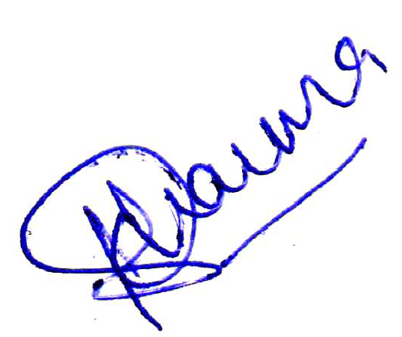
Date: 31/01/2017 (Saurabh Sharma)

